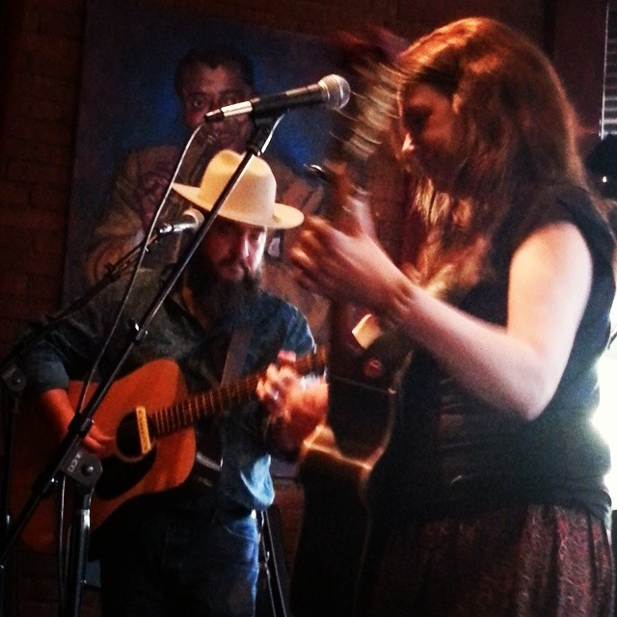
Biography
Sands & Hearn are husband and wife singer/songwriters Quinn Sands and Richard Hearn, out of Cleveland, Ohio. Both Quinn and Richard are multi-instrumentalists who began writing and performing together shortly after meeting in June of 2015. Their style is best described as alt. folk/rock Americana - a unique blend of their musical backgrounds and influenced by the roots of American music, with an emphasis on the story and sweet harmonies.

In 2017, they released their first album, entitled Time Is A Line, which features a line-up of some of the most talented musicians from Northeast Ohio. Ireland’s Lonesome Highway Magazine published a review of Time Is A Line, by reviewer/writer Paul McGee, who also included it in his Best of 2017 Year End list.

Live, they’ve performed primarily as a bass & guitar duo, often switching to various other instruments such as glockenspiel, Shruti-box and various percussion (often played with their feet) at venues around the Northeast, Ohio, such as the Beachland Ballroom & Tavern, Brother’s Lounge and at the legendary Barking Spider Tavern. They’ve also performed at the Painesville Party in the Park, Spice Acre’s Plated Dinner events, the Lorain County Fair, Walk All Over Waterloo, the 2018 Lake Erie Folk Festival, Riverdog Music in Wakeman, OH, The Factory in Sharon, PA, the Music the Bloom Café & Listening Room in Bristol, TN.
They have opened for such legendary performers as Tommy Womack, Ray Bonneville, Maria Muldaur, Rod Picott and Kevin Gordon, as well as The Ragbirds and Brent Cobb. In 2018, they performed in Dublin, Ireland at the legendary Whelan’s Bar (in support of Brent Cobb) and The Underground Live Music Venue.
Other influences include:
White Horse
Shovels & Rope
The Mastersons
Robert Plant/Patty Griffin
Jeffrey Foucault & Kris Delmhorst

Contact Info:
Quinn Sands & Richard Hearn
216.857.3539
sandshearnmusic@gmail.com
http://www.sandshearnmusic.com

